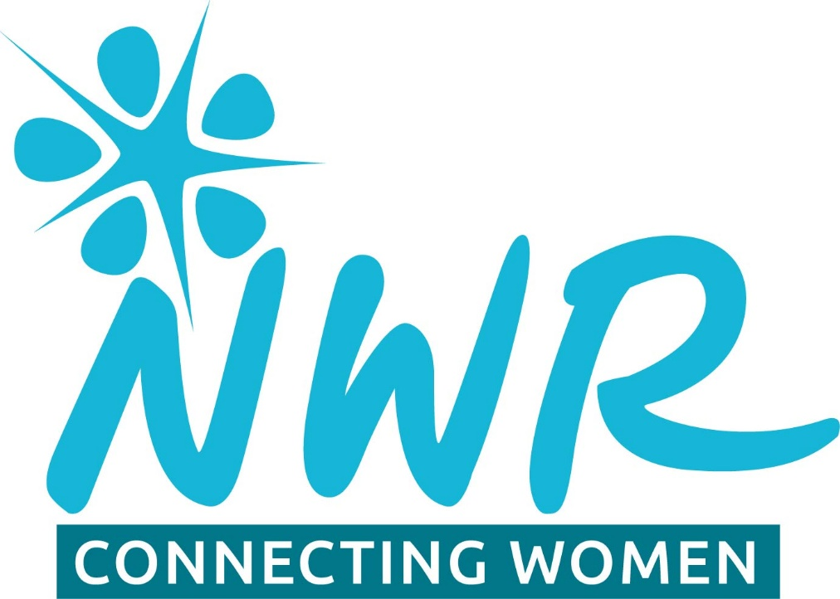
Sheffield
South West Programme
2026

Date | Theme
Monday 26th January | Programme planning for 2026
Tuesday February 17th. | Comfort Food. – What is everyone’s go to comfort food? Is it linked to seasons/childhood or anything else. All to bring examples of own comfort food to share.
Wednesday March 18th. | The Ripple Effect – discussion around social media and should it be banned?
Thursday April 23rd | Board game evening at Tree House café. Debbie to book.
Monday May 11th. | Iceland (National theme). All to bring some information of your choice. Debbie will do slide show. Chris will talk about birds. Wendy will make a cake or sweet to share.
June | Summer tapas. We will be going for a Tapas meal, hopefully in Moraira, Totley. Date to be confirmed.
Tuesday July 21st. | Origin of names. Research and discussion around origin of mother’s name. Can be maiden name or Christian name (or even both)
Weds August 19th. | 100 years ago. Pick a key event from 1926. Discussion around how this may still be affecting us today.
Thursday September 17th. | The importance of AI. Discussion around the positives and negatives of AI.
Monday October 19th. | NWR Big Read. Everyone to choose a book of their choice from the book list. https://nwr.org.uk/news/nwr-2026-big-read-2/. Discussion around the chosen book will lead to recommendations for others to read too, setting up a reading list for those that want it. If time allows discussion can also ensue around other books people have enjoyed.
November | Telephone Treasure Trail. Day/date to be confirmed
December W/C 30/11 | Christmas meal. Day/date to be confirmed.
Tuesday January 19th | Programme planning meeting.

All meetings to start at 7.30pm unless stated otherwise on Programme.

We will also be doing the following at convenient times:
- Visit to Old Moor Nature Reserve, RSPB near Barnsley. This will be in May and Chris will be leading.
- Street Art Tour in a chosen area of Sheffield.
- Afternoon tea/ art class at Moraira.
- Visit to a local Christmas Tree festival.

Coffee mornings, walks and other visits will be arranged on an informal basis.

Local Organiser Wendy Crowder

w.crowder44@gmail.com

NWR is a Registered Charity No. 295198



