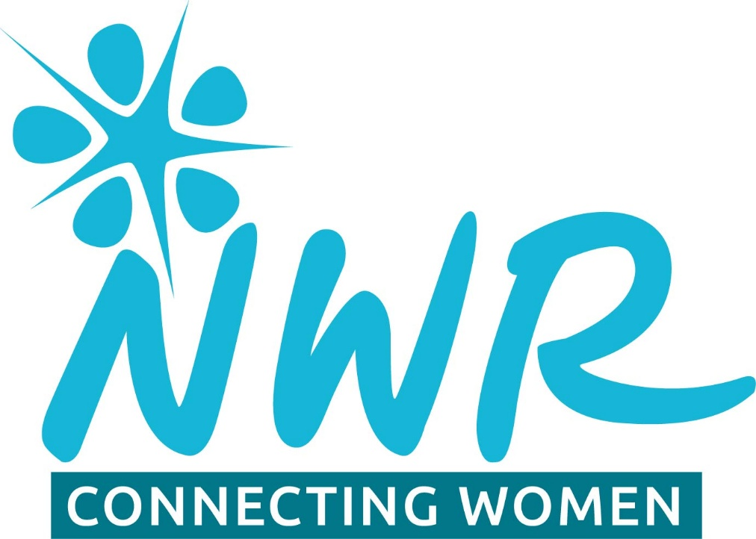
Sheffield
South West Programme
2025

Date | Theme
Wednesday  26TH Feb 2025 | Country Theme for 2025 is Channel Islands. Bring photos/memories to discuss. Choose a topic to add interest such as history, geography, wildlife.
Thursday  27th March 2025 | Pub quiz, Shepley Spitfire 7pm start.  Table will be booked. In line with connections theme will be connecting with local community and raising awareness of NWR.
Tuesday 22nd April 2025 | Saturday jobs and dream jobs.  What Saturday jobs did you have and how did this set you up for your working life.  If you could choose a different career path what would it be or do/did you follow your dream job?
Weds 21st May 2025 | How people lived during the war.  Linking with VE Day celebrations this month and connecting with older people, talking to them about their life during the war .Bringing memories together. Bring along any memorabilia.
Thurs. 26th June 2025 | Meal  To meet at Ego, Dore Moor.
Friday 11th July | Exploring the Chesterfield Canal.  Afternoon tea on the John Varley 11, supporting the restoration of the Chesterfield Canal and learning about life on the canal and the wildlife.
Weds 27th Aug 2025 | Garden meeting.  Afternoon tea in Wendy’s garden. Discussion around plants and plant swap for those who wish.
Monday 22nd September | Book Discussion.  Our choice from suggested list is Orbital by Samantha Harvey
Tuesday 21st October | Choose a poem.  Bring a favourite poem to read out and discuss.
Weds 12th Nov.2025 | NWR Telephone Treasure Trail
December 2025 | Christmas meal.  Date/time /venue tbc. Will be day time.
Mon 26th Jan 2026 | Planning meeting for 2026

All meetings to start at 7.30pm unless stated otherwise on Programme

Coffee mornings, walks and visits will be arranged on an informal basis.

Local Organiser Wendy Crowder

w.crowder44@gmail.com

NWR is a Registered Charity No. 295198



